Leaving Cert Physics Worked Solutions 2015

2015 Question 1
- Describe, with the aid of a labelled diagram, how the student obtained the data
• volume scale • pressure gauge • method of changing volume/pressure
Labelled column of air/gas
Read pressure (from gauge) and volume (from scale)
Change pressure/volume (and repeat measurements)

- Draw a suitable graph to show the relationship between the pressure of the gas and its volume.

p (kPa) | 0.0125 | 0.0083 | 0.0063 | 0.005 | 0.0042 | 0.0036
1/V (cm⁻³) | 324 | 214 | 165 | 135 | 112 | 100
Reciprocal values for p or V
Label axes
5 points correctly plotted
Straight line with good fit

- Explain how the graph verifies Boyle’s law.
Statement: Straight line through origin shows that pressure is inversely proportional to volume

- Use your graph to estimate the pressure of the gas at a volume of 250 cm³.
Correct use of graph
p ≈ 108 kPa

- Why might the temperature of the gas have changed significantly during the experiment?
Changing the volume (or pressure) quickly would cause a change in temperature of the gas.
- How did the student ensure that the temperature of the gas was the same for each measurement?
Wait to make readings after changing volume/pressure

2015 Question 2
- Draw a labelled diagram of the apparatus used in the experiment.
Polystyrene cup with water, Steam generator, Point of detail (thermometer, steam trap, lagging, lid, mass balance, delivery tube)

- State two assumptions that the student made about the polystyrene cup when carrying out this calculation.
That it is a good/perfect insulator
That it has a low/negligible heat capacity / specific heat capacity / that it does not gain heat

- Use the data given above to calculate the specific latent heat of vaporisation of water.
Heat lost by steam changing state + heat lost by condensed steam cooling down = heat absorbed by water

ml_{steam} + mcΔθ_{condensed_steam} = mcΔθ_{water}
Δθ_{condensed_steam} = 70 K
Δθ_{water} = 19 K
m_{s} = 0.0026 kg
m_{w} = 0.0834 kg

(0.0026 × l) + (0.0026)(4180)(70) = (0.0834)(4180)(19)
l = 2.25 × 10⁶ J kg⁻¹

- How did each of these steps improve the accuracy of the experiment?
Calculations assume that only steam is added / no water was added // Otherwise the steam would have lost its latent heat (of vaporisation)
(ii) Energy/heat gained = energy/heat lost

2015 Question 3
- Draw a labelled diagram of the apparatus used in the experiment.
Diagram: diffraction grating, laser labelled, screen (+ metre stick)

- How were the first order images identified?
They were (immediately) to either side of the zero order image / straight through image / central image / brightest image / image observed when no grating was present

- How was a beam of light produced?
Laser

- Which of the four θ angles is the most accurate? Suggest a reason for your answer.
n = 4 This is the largest angle therefore smallest % error
OR
n = 1 because this is the sharpest image

- Calculate the wavelength of the monochromatic light.
d = 1/80000 = 1.25 × 10^{–5} m
The angles are between the first order image to the left and the first order image to the right so this needs to be divided by 2 for each calculation.
nλ = d Sin θ
Repeat for each angle and take the average.
λ ≈ 5.0 × 10^{–7} m

- What would be the effect on the pattern produced if this diffraction grating was replaced with a diffraction grating of 500 lines per mm?
Images more spread out / larger angles / Fewer images seen

2015 Question 4

- Using the recorded data, plot a graph to show the variation of the resistance of the metallic conductor with its temperature.
Correctly labelled axes
7 points correctly plotted
Straight line with good fit

- Use your graph to estimate the rate of change of resistance with respect to temperature for the metallic conductor
Correct rate/slope from graph ≈ 0.033 $Ω$ K⁻¹

- Use your graph to estimate the resistance of the metallic conductor when it is immersed in melting ice.
correct intercept / Correct use of rate/slope
R ≈ 5.5 Ω

- Describe, with the aid of a circuit diagram, how the student carried out this second experiment
• circuit • power supply/battery • variable (p.s.u) / variable resistor • ammeter • voltmeter • filament bulb
Correct arrangement – voltmeter across filament bulb, ammeter in series
Measure voltage and current
Vary voltage (and repeat measurements)

- Use the findings of the first experiment to explain the shape of the graph in the second experiment.
Temperature increases as current increases
Resistance increases as temperature increases

2015 Question 5

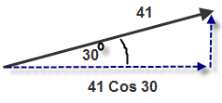  A hurler strikes a sliotar with an initial velocity of 41 m s^{–1} at an angle of 30° to the horizontal. How far does the ball travel horizontally in three seconds? | First we need to work out how fast the ball is travelling in the horizontal direction.  So we need to calculate the horizontal component of the initial velocity:  v_{Horizontal} = 41Cos30⁰ = 35.51 m s^{–1}  Then use s = (velocity)(time)  s = (35.51)(3) = 106.52 m
Describe the movement of a particle that is undergoing simple harmonic motion. | An object is said to be moving with simple harmonic motion if;  its acceleration is directly proportional to its displacement from a fixed point in its path, and its acceleration is directed towards that point.
The refractive index of haematite is 3.2. What is its critical angle? | n = 3.2 $n=\frac{1}{sin C}$ $\sin{C}=\frac{1}{n}$ $\sin{C}=\frac{1}{3.2}$  sin C = 0.3125 C = $\sin^{-1}{0.3125}$  C = 18.21°
What frequency would be detected by an observer when a source emitting a sound of frequency 512 Hz approaches at a velocity of 28 m s^{–1}?  Speed of sound in air = 340 m s^{–1} | f = 512 Hz  u = 28 m s^{–1}  c = 340 m s^{–1} $f^{'}=\frac{(f)(c)}{c-u}$  $f^{'}=\frac{(512)(340)}{340-28}$ $f^{'}$ = 557.95 Hz
Calculate the energy from the Sun falling on a football pitch of dimensions 106 m × 68 m in 90 minutes.  Solar constant = 1.36 kW m^{–2} | Time in seconds = 90 × 60 = 5400 s  Area =106 × 68 = 7208 m²  1.36 kW = 1360 joules per sec  1.36 kW m^{–2} means that 1360 joules of energy fall each second on one square metre.  So total energy falling = (1360)(5400)(7208) joules = 5.3 × 10¹⁰ J
Write an expression for the charge stored on one plate of a parallel plate capacitor in terms of the potential difference between the plates, their common area, the distance between them and the permittivity of the dielectric. | $C=\frac{Q}{V}$ and $C=\frac{eA}{d}$  $\frac{Q}{V}=\frac{eA}{d}$ $→$ $Q=\frac{eAV}{d}$
Define the ampere, the SI unit of current | The ampere is that unit of current which, if flowing in two parallel conductors placed one metre apart in a vacuum, will cause a force of 2 × 10^{–7} N m⁻¹ to be exerted on each conductor.
Name the wire that contains the fuse in a three-pin plug. What colour is this wire? | Live. The colour is brown.
The first artificial transmutation of an atom was achieved by Rutherford in 1919.  An alpha-particle collided with a nitrogen–14 nucleus to create an isotope of oxygen and a proton. Write a nuclear equation for this transmutation. | $$N_{7}^{14}{+ He}_{2}^{4}→ {+O}_{8}^{17}{+ H}_{1}^{1}$$
Give the quark composition of  (i) the proton and (ii) the anti-neutron. | - up, up, down  - anti-up, anti-down, anti-down

2015 Question 6

- Explain what is meant by centripetal force.
The force - acting in towards the centre - required to keep an object moving in a circle is called centripetal force.
- State Newton’s law of universal gravitation.
Newton’s law of gravitation states that any two point masses in the universe attract each other with a force that is directly proportional to the product of their masses and inversely proportional to the square of the distance between them.

- Derive the relationship between the period of a satellite, the radius of its orbit and the mass of the Earth.
Centripetal force = gravitational force
$$\frac{mv^{2}}{r}=\frac{Gm_{1}m_{2}}{d^{2}}$$

Cancel one m on both sides. The r and d both correspond to the same thing, so we can also cancel the r on the left hand side with one of the d’s on the right hand side.

So we are left with $v^{2}=\frac{Gm}{r}$ Equation (1)

$speed= \frac{distance}{time}$
Distance in this case is the circumference of a circle (2πR for circular satellite orbits)
The time corresponds to the time for one compete orbit, so we give it the symbol T.
We also allow v to represent speed (even though technically v represents velocity, which is not the same)

⇒ ⇒ (square both sides) Equation (2)

Equating Equations (1) and (2) we get
$\frac{Gm}{r}=$
⇒

- Calculate the height of a GPS satellite above the Earth’s surface.
T = 12 hours = (12)(60)(60) = 43200 seconds
Mass of Earth = 5.97 ×10²⁴ kg
Radius of Earth = 6.371 ×10⁶ m
G = 6.7 x 10⁻¹¹ N m² kg⁻²

R = 2.66 × 10⁷ m
h = (2.66 × 10⁷ – radius of the earth) = 2.023 × 10⁷ m

- Calculate the speed of a GPS satellite.
$$v^{2}=\frac{GM}{R} \\ v^{2}=\frac{(}{2.66 × {10}^{7}}$$
v = 3.869 × 10³ m s^{–1}

- Calculate the minimum time it takes a GPS signal to travel from the satellite to a receiver on the surface of the Earth.
$$speed=\frac{distance}{time}$$

Speed = speed of radio wave which travels at the speed of light: 3×10⁸ m s⁻¹
Distance travelled = distance from satellite to surface of the Earth = 2.023 × 10⁷ m
$$time taken=\frac{distance travelled}{speed}=\frac{2.023{×10}^{7}}{3×{10}^{8}}$$
time = 0.067 seconds

- Explain why GPS satellites are not classed as geostationary satellites.
Periodic time of the satellite is 12 hours, while the periodic time of the Earth is 24 hours (so the satellite won’t always be over the same spot on the Earth).

What type of electromagnetic radiation has the next lowest frequency?
Microwaves

2015 Question 7

Describe, with the aid of a labelled diagram of an X-ray tube, how X-rays are produced.
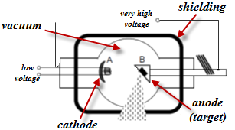
- The low voltage supplies power to a filament which in turn heats the cathode at A.
- Electrons are emitted from the hot cathode due to thermionic emission.
- They get accelerated across the vacuum due to the very high voltage and smash into the high-density anode (usually tungsten) at B.
- Most of the kinetic energy gets converted to heat, which must be removed with a coolant.
- Some inner electrons in the tungsten get bumped up to a high orbital, then quickly fall back down to a lower lever, emitting X-rays in the process.
- These X-rays are emitted in all directions.
- Most of these get absorbed by the lead shielding, but some exit through a narrow window, where they are then used for the required purpose.

- A potential difference of 50 kV is applied across an X-ray tube.
Calculate the maximum velocity of an electron in the tube.
electrical potential energy at the beginning = kinetic energy of the electron at the end:
QV = ½ mv_{el}²

${vel}^{2}=\frac{2QV}{m}$ ${vel}^{2}=\frac{{(1.6 × 10}^{-19})(50000)}{{9.1× 10}^{-31}}$ $=1.69×{10}^{16}$ vel = 1.3 × 10⁸ m s^{–1}

- Calculate the minimum wavelength of the X-rays produced by the tube.
In this case we assume that the potential energy at the beginning gets converted into X-rays which are electromagnetic radiation.
The energy associated with electromagnetic radiation is given by the equation E = hf
Electromagnetic energy at the end = Potential energy at the beginning
hf = QV
Now we don’t know the frequency, but we do know the relationship between frequency and wavelength: c = fλ $f=\frac{c}{λ}$
So we have $h\frac{c}{λ}=QV$ $λ=\frac{ch}{QV}$
c = speed of light h = Planck’s constant Q = charge on an electron V = potential difference

$λ=\frac{{(3.0 × 10}^{8})({6.6 × 10}^{-34})}{({1.6 × 10}^{-19})(50000)}$ λ = 2.5 × 10^{–11} m

- What is the photoelectric effect?
The photoelectric effect is the emission of electrons from a metal due to electromagnetic radiation of a suitable frequency falling upon it.
- Describe a laboratory experiment to demonstrate the photoelectric effect.
Apparatus: Gold leaf electroscope with zinc plate on top.
Procedure:
Charge the electroscope negatively.
Shine ultraviolet light on the zinc plate.
Result: The leaves fall together

- Outline Einstein’s explanation of the photoelectric effect.
- The energy coming from the UV lamp travels in packets called ‘photons’.
- If the photons contain enough energy they can get absorbed by an electron on the surface of the zinc metal.
- Each photon gives all its energy to one electron
- A certain amount of this energy (known as the work function) goes to liberating (releasing) the electron. The remainder appears as kinetic energy of the liberated electron.

2015 Question 8
- Define electric field strength.
E = force per unit charge
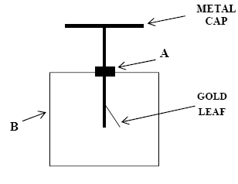
- Draw a labelled diagram of a gold leaf electroscope.
A = insulated joint, B = metal case
Marking scheme:
Metal cap attached to gold leaves
Metal case (and glass window)
Both the cap and the leaves are insulated from the case

- Describe how it can be given a negative charge by induction.
- Bring a positively-charged rod close to the cap of the electroscope.
- Keeping the charged rod in place, earth the conductor by touching it with your finger.
- Remove your finger, then and only then remove the rod.

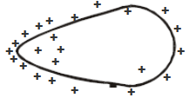
- Explain, with the aid of a labelled diagram, how point discharge occurs.
- Diagram with concentration of charge at point
- If the build-up of charge at the pointed end is sufficiently large (large electric field) charges leave the pointed end and accelerate away.
- They collide with and ionise atoms/molecules in the air.
- Negative ions in the air accelerate towards the pointed end and neutralise the existing charges.

- Describe an experiment to demonstrate point discharge.
Attach a nail to the surface of a Van der Graff generator.
Bring up a candle and notice that the flame moves away from the Van der Graff. This is because of the ‘wind’ generated by point discharge.

- What is the electric field strength at a point 4 cm from the surface of the dome?
The ‘distance’ in relation to electric field strength corresponds to the distance to the centre of the dome (similar to centre of gravity of a planet being in the middle of the planet).
d = 4 + 20 = 24 cm = 0.24 m
$$E=\frac{Q}{4πd^{2}}$$

$$E=\frac{{3.8×10}^{-6}}{(4)(π{)(8.9×10}^{-12}{)({0.24)}^{2}}^{}}$$
E = 5.9 × 10⁵ N C^{–1} away from the centre of the dome

2015 Question 9

- What are stationary waves? How are they produced?
The amplitude of the wave at any point is constant // There is no net transfer of energy

- What is resonance?
Transfer of energy between two bodies with the same (or similar) natural frequency
OR Resonance is the transfer of energy so that a body vibrates at its natural frequency.
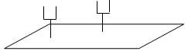
- Describe a laboratory experiment to demonstrate resonance.
Use two identical tuning forks (same frequency) and a sound-board.
Start one fork vibrating, place it on the sound-board and notice the sound.
Place the second tuning fork on the sound-board and then stop the first tuning fork from vibrating.
The second fork can now be heard.
Explanation:
The vibrations were passed from the first tuning fork via the sound-board to the second tuning fork.

- What are the two other factors?
Length and mass per unit length

- What effect does increasing the tension of the string from 36 N to 81 N have on the frequency of the string?
Tension increased by a factor of 2.25 (81$÷36)$
f $∝$ $\sqrt{T}$$$\sqrt{2.25}=1.5$$frequency increases by a factor of 1.5

- Explain, with the aid of labelled diagrams, why a pipe open at only one end produces half the number of harmonics as a pipe open at both ends.

Harmonics in a pipe open at both ends Harmonics in a pipe open at one end

I don’t understand this one: In theory you can get an infinite number of harmonics in both open and closed pipes. What am I not seeing here?

For what it’s worth, the following is the marking scheme for this section:
Diagram of first harmonic for open pipe (3)
Diagram of other harmonic for same open pipe (3)
Diagram of first harmonic for closed pipe (3)
Diagram of other harmonic for same closed pipe (3)
All harmonics for open pipe, only odd harmonics for closed pipe (2)
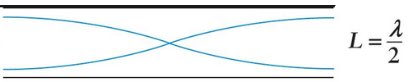
- How long is the pipe?

From the diagram we can see that the length of the pipe corresponds to half the wavelength.
l = λ/2, so if we can work out the wavelength we can calculate the length from there.

v = fλ ⇒ $=\frac{v}{f}$ ⇒ $=\frac{340}{587}$
λ = 0.58 m

l = 0.29 m

2015 Question 10 (a)
- What is the principal force that neutrinos experience? Weak (nuclear force)

- Name two other leptons. Muon, tau, positron

- Name one fundamental particle that is subject to the strong nuclear force. Quark

- Why did he make this proposal? Momentum/energy not conserved

- Write a nuclear equation to represent beta-decay.
$$n_{0}^{1}→H_{1}^{1} {+e}_{-1}^{0}+v$$

- Calculate the energy released, in MeV, during beta-decay.
Page 46, 47 and 48 of log tables to get values for the mass of the particles.

Mass of neutron: 1.674 927 28 × 10⁻²⁷ kg Mass of proton: 1.672 621 71 × 10⁻²⁷ kg
Mass of electron: 9.109 3826 × 10⁻³¹ kg
Mass of neutrino: see page 48 of log tables; the mass of the neutrino is given relative to the mass of an electron. Mass of neutrino = (4.305 × 10⁻⁶)(9.109 3826 × 10⁻³¹) = 3.921589209 × 10⁻³⁶ kg

Mass before = mass of neutron= 1.674 927 28 × 10^{–27} kg

Mass after = mass of proton + mass of electron + mass of neutrino
= 1.672 621 71 × 10⁻²⁷ kg + 9.109 3826 × 10⁻³¹ kg + 3.921589209 × 10⁻³⁶ kg

Total mass after = 1.673532652 × 10⁻²⁷ kg

Loss in mass = total mass beforehand – total mass afterwards
= (1.674 927 28 × 10^{–27} kg) – (1.673532652 × 10⁻²⁷ kg)

Loss in mass = 1.395 × 10^{–30} kg
To calculate the energy associated with this mass we need to use E = mc²
E = (1.395 × 10^{–30})(2.997 924 58)² E = 1.25 × 10⁻¹³ J

Now we need to convert from Joules to eV
1 eV = 1.602 176 53 × 10⁻¹⁹ J {page 46 of log tables}

So we need to divide 1.25 × 10⁻¹³ by 1.602 176 53 × 10⁻¹⁹ E = 780188 eV
Now divide by 1×10⁶ to convert to MeV {M = mega = 10⁶} E = 0.78 MeV

- However it is much more difficult to detect a neutrino. Explain why.
The neutrino has no charge and only a very small mass.

- Calculate the radius of the circle when the electron has a speed of 1.45 × 10⁸ m s^{–1}.

The force experience by a charged particle in a magnetic field is given by the equation F = Bqv.
The force experience by a particle moving in a circle is given by the equation F = mv²/r
Equating both expressions:
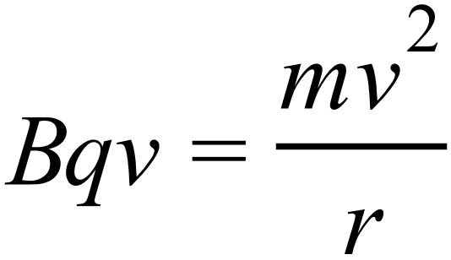 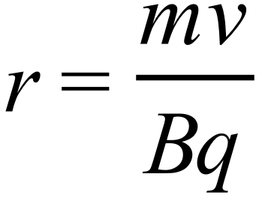 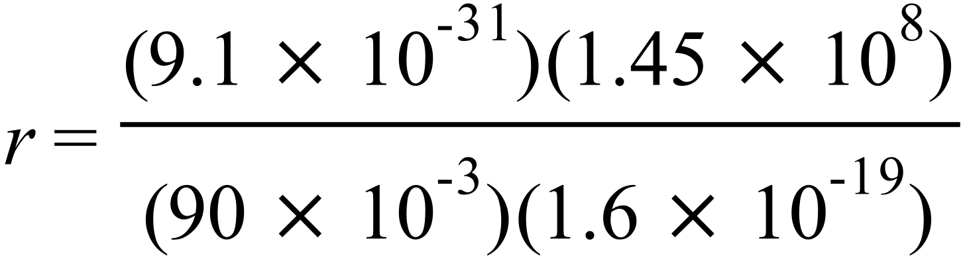 r = 9.16 × 10^{–3} m

Describe the path of a neutrino in the same magnetic field.
No deviation
2015 Question 11
- Define the tesla.
A magnetic flux density of one Tesla corresponds to a current of 1 A flowing through a wire of length 1 m causing a force of 1 N.

- Sketch voltage-time graphs for (i) an a.c. supply and (ii) a d.c. supply.
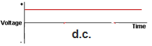
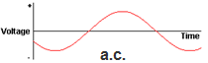

- Explain the term electromagnetic induction.
Electromagnetic Induction occurs when an emf is induced in a coil due to a changing magnetic flux.

- Why does a transformer not work with direct current?
The current is not changing therefore the magnetic flux is not changing, therefore there is no induced emf.

- Why is it inefficient to use low voltage when transmitting electricity?
Low voltage means large currents which would result in more heat lost (than if the current were low).

- The peak voltage of an a.c. supply is 321 V. Calculate the rms voltage.
V_{rms} = $\frac{V_{max}}{\sqrt{2}}$ = $\frac{321}{\sqrt{2}}$ = 227 V
- Explain why it is necessary to use rms values when comparing a.c. and d.c. electricity.
So as to make the power output equivalent between a.c. and d.c.

- Give one advantage and one disadvantage of electric cars.
Advantage: e.g. fewer carbon emissions
Disadvantage: e.g. short range / expensive batteries

2015 Question 12 (a)

- State Newton’s second law of motion.
Newton’s second law of motion states that the rate of change of an object’s momentum is directly proportional to the force which caused it, and takes place in the direction of the force.

- What is the principal energy conversion that is taking place as the skier travels along the course?
(Gravitational) potential energy to kinetic energy

- Ignoring friction, calculate her maximum velocity when she has travelled 400 m.
mgh = ½mv²
v =√2gh v =√(2)(9.8)(90) v = 42 m s^{–1}

- She then ploughed into a snow drift and came to a stop in a time of 0.8 seconds.
What is the force that she exerts on the snow drift?
F = rate of change of momentum
F = (mv – mu)/t
The skier was travelling at 42 m s⁻¹ when she ploughed into the snowdrift, so initial velocity is 42 m s⁻¹ and final velocity is zero.
F = {(71)(0) – (71)(42)}/0.8
F = 3727.5 N

- What force does the snow drift exert on her?
F = 3727.5 N in opposite direction

2015 Question 12 (b)
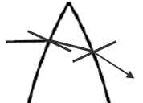
- Copy the diagram on the right into your answer book and complete the path of the light ray through the section of the lens.

At the first interface the light ray is travelling from a medium of low refractive index to a medium of higher refractive index and so bends towards the normal.
The opposite happens at the second interface (light ray bends away from the normal).
The opposite happens at the second interface (light ray bends away from the normal).
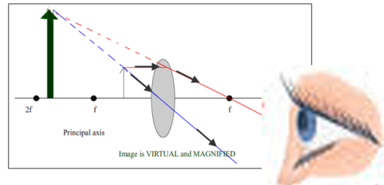
- Draw a ray diagram to show the formation of a virtual image in a converging lens.
See diagram

- Calculate the power of the combination.
P_{total} = P₁ + P₂ $P=\frac{1}{f}$
P₁ = $\frac{1}{0.2}$ = 5 m⁻¹ P₂ = $\frac{1}{-0.08}$ = -12.5 m⁻¹ {the second lens is diverging and so is negative}
P_{total} = 5 – 12.5 m⁻¹ P_{total} = –7.5 m^{–1}

- What eye defect can be corrected using converging lenses?
Long-sightedness

2015 Question 12 (c)
- Explain the underlined terms.
Thermometric property: one that changes (measurably) with temperature
Emf: A voltage when applied to a full circuit is called an emf (electromotive force).

- What is the SI unit of temperature?
Kelvin / K

- Give an advantage of using this unit in scientific measurements.
Temperature is always positive

- Describe a laboratory experiment to demonstrate the principle of operation of a thermocouple.
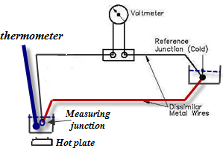
- A thermocouple is comprised of two different metals joined together at both ends to form two junctions.
- One junction is connected to a liquid of known temperature like ice-water which would be at 0 ⁰C; this is the cold or reference junction.
- The other junction is connected to the liquid whose temperature is to be measured.
- An emf /voltage is produced (as seen in the diagram).
- Increase the temperature of the heat source and note the new temperature (using an existing thermometer) and new voltage.
- Plot a graph of emf against temperature.
- You can now use the graph with this thermocouple to establish the temperature of the liquid in the future (dip the measuring junction into the liquid note the voltage and use the graph to get the corresponding temperature).

- Give an advantage of using a thermocouple thermometer instead of a mercury-in-glass thermometer.
Less fragile, wider temperature range, mercury is toxic etc.

2015 Question 12 (d)
- What is meant by the term radioactive?
An atom is radioactive if its nucleus undergoes spontaneous disintegration with the emission of one or more types of radiation

- Name a detector of radiation and describe, with the aid of a labelled diagram, its principle of operation.
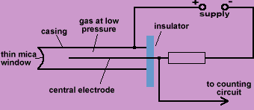
- Radiation enters through the thin window on the left.
- It causes ionisation of some of the rare-earth gas molecules inside.
- The negative ions (electrons) accelerate towards the anode, colliding off (and ionising) other gas molecules along the way, giving rise to an avalanche effect.
- These ions all reach the anode more or less together and are detected as a pulse.

- How many radon–210 atoms will remain after one day?
The sample of the gas contains 4.5 × 10¹⁵ atoms and this number halves after each half life.
The number of minutes in a day = 24 × 60 = 1440 minutes

The half-life of radon-210 is 144 mins, so there are 10 half-lives in one day.
(4.5 × 10¹⁵) × ½ × ½ × ½ × ½ × ½ × ½ × ½ × ½ × ½ × ½ = 4.4 ×10¹² atoms

